📜 Release Final Grade & View Grades as Student in D2L Brightspace
Ensure students can see their final grades and check how their grades appear from their perspective.

🔓 Release Final Grade to Students
📌 Why Release Final Grades?
✅ Provides Transparency – Students can see their final course standing.
✅ Prevents Grade Confusion – Avoids students thinking their grade is incomplete.
✅ Allows for Final Review – Gives students a chance to clarify any grading concerns.
✅ Default on for fresh course shells – Already on unless you have copied from a course that didn’t have it turned on.

🛠 How to Release Final Grades in D2L Brightspace
Enable "Release Final Grades" in Course Settings
- Go to "Grades" from the Navbar.
- Click "Settings" (top-right corner).
- In the "Calculation Options" tab:
  - Select "Automatically release final grade" (if you want grades released instantly).
  - Otherwise, choose "Manually release" for more control.
  - I also like to verify that Calculated Final Grade is marked.
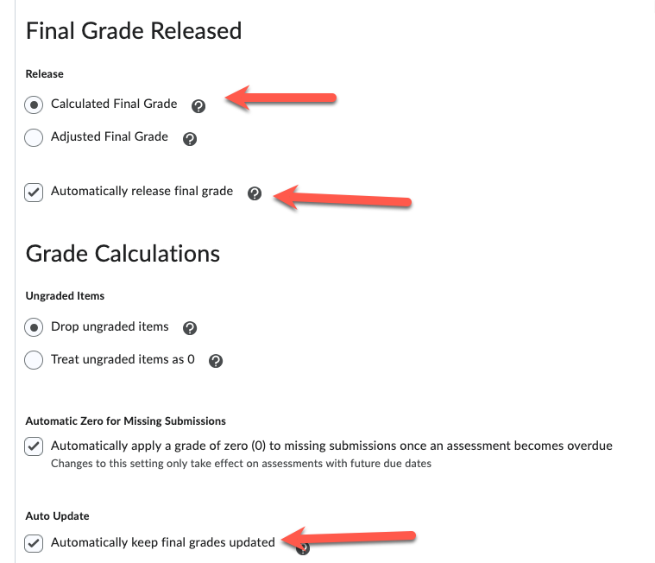
- Click Save and Close.
Manually Release Final Grades (If Auto-Release is Disabled)
- Go to "Grades" then on Enter Grades tab".
- Find the "Final Calculated Grade" or "Final Adjusted Grade" column (usually the first column).
- Click the dropdown menu next to that grade item and click Enter Grades
- Click the dropdown menu next to "Final Grades" (at the top left) → Select "Release All".
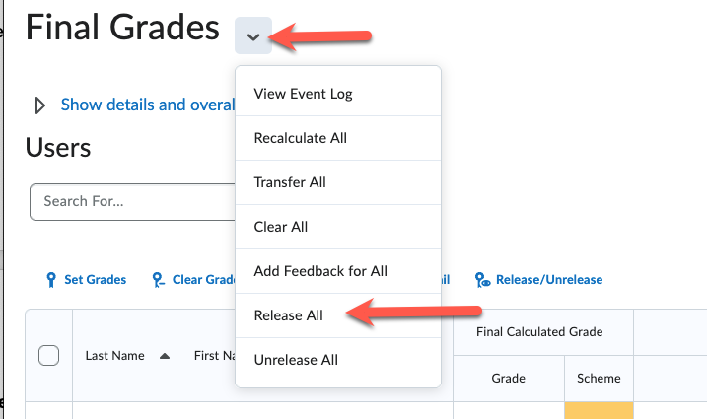
- Confirm and Save.
📌 Effect: Students will now see their final grades in their "Grades" area.

👀 View Grades as a Student
📌 Why View Grades as a Student?
✅ Ensures Gradebook Displays Correctly – Check for miscalculations.
✅ Helps Answer Student Questions – See exactly what they see.
✅ Verifies Grade Schemes & Visibility – Ensure letter grades or percentages appear as intended.

🛠 How to View Grades as a Student in D2L Brightspace
- Go to "Grades" in the Navbar.
- Locate a student, click the dropdown next to their name, and select "Preview".
- You'll see their gradebook exactly as they do.
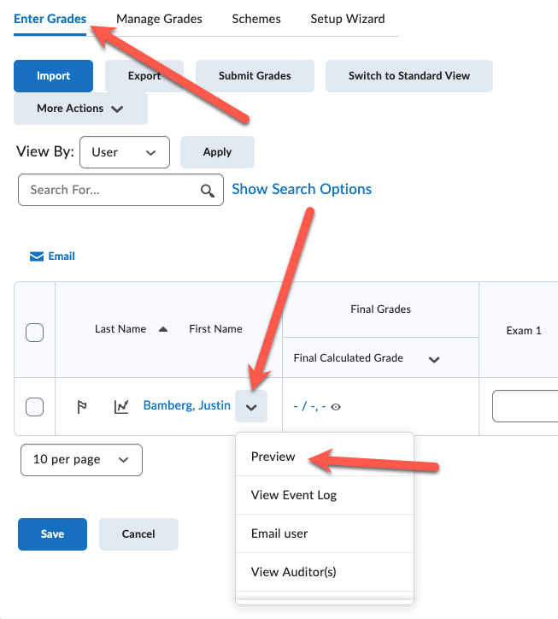

🛠 Example Scenarios for Final Grades & Student View
Scenario | Feature Used
Ensure students see their final grades. | Release Final Grades
Check how a specific student views their grades. | Preview Grades
Confirm Grade Scheme visibility (A, B, C instead of %). | Preview Grades
Fix incorrect grade visibility settings. | Adjust Gradebook Settings & Re-release

💡 Additional Tips & Best Practices
✅ Use "Final Adjusted Grade" for Manual Adjustments – If you need to curve or override a grade.
✅ Enable Auto-Release for Faster Communication – Reduces last-minute manual grading tasks.
✅ Test "Preview" Before Course Ends – Avoid surprises in final grade visibility.

